PROJECT PROPOSAL REPORT
Smart Museum Visitor Experience
and Artifact Monitoring Platform
An AI, IoT, RFID and Augmented-Reality Driven System for Personalized Engagement and Cultural Heritage Preservation
Prepared for: Museum Digital Transformation Initiative
Document Type: Technical & Strategic Report
Date: July 2026

Table of Contents
1. Executive Summary
2. Industry Context
3. Problem Statement
4. Objectives
5. Proposed System Architecture
6. Key Features and Functional Modules
7. Technology Stack Overview
8. Expected Outcomes
9. Conclusion

1. Executive Summary
Museums are custodians of irreplaceable cultural heritage, yet many continue to rely on manual processes for artifact conservation and offer limited, static forms of visitor engagement. This report presents a proposal for a Smart Museum Visitor Experience and Artifact Monitoring Platform that unifies Internet of Things (IoT) sensing, Radio-Frequency Identification (RFID), Augmented Reality (AR), Artificial Intelligence (AI), and cloud computing into a single integrated system.
The platform is designed around two complementary goals: protecting the long-term physical integrity of artifacts through continuous environmental and security monitoring, and elevating the visitor experience through AI-driven personalization and immersive AR-based interpretation. In doing so, the system directly addresses the operational, curatorial, and experiential gaps present in conventional museum management approaches.
This document outlines the industry context, problem statement, project objectives, proposed system architecture, core functional modules, technology stack, and the expected outcomes of the platform, providing a foundation for planning, stakeholder alignment, and phased implementation.

2. Industry Context
The global museum sector is undergoing a significant digital transformation. Institutions are increasingly adopting connected technologies — AI, IoT, AR, RFID, and cloud computing — to modernize how they manage collections and engage the public. This shift is driven by rising visitor expectations for interactive, personalized experiences, alongside a growing recognition that environmental variables such as temperature, humidity, and light exposure directly affect the physical condition of artifacts over time.
At the same time, museums operate under tight budgetary and staffing constraints, making it essential that any new technology investment deliver measurable value across multiple dimensions simultaneously: preservation, security, operational efficiency, and visitor satisfaction. A converged, data-driven platform — rather than a set of disconnected point solutions — is therefore the direction the industry is moving toward.

3. Problem Statement
Museums face three interconnected challenges that conventional systems are poorly equipped to solve:
- Preservation risk: Limited real-time visibility into the environmental conditions surrounding sensitive artifacts, which increases the risk of undetected degradation from temperature or humidity fluctuations.
- Engagement gap: Static, one-size-fits-all visitor experiences that do not adapt to individual interests, resulting in reduced engagement, uneven visitor flow, and underused exhibition space.
- Security exposure: Fragmented or manual security monitoring processes that slow the detection of unauthorized access, tampering, or theft attempts involving high-value collections.
A smart museum platform is needed that can monitor artifact temperature, humidity, and security using IoT sensors; deliver AI-powered personalized tour recommendations; integrate AR-based interactive exhibits; and analyze visitor behavior to optimize exhibition layouts — improving visitor satisfaction while safeguarding cultural heritage for future generations.

4. Objectives
The platform is guided by eight core objectives spanning preservation, engagement, and operational performance:
- Monitor artifact environmental conditions (temperature, humidity, light) in real time using IoT sensors.
- Track visitor movement and engagement patterns throughout the museum using RFID, beacons, and app telemetry.
- Provide AI-based personalized tour recommendations tailored to individual visitor interests and available time.
- Integrate Augmented Reality (AR) for interactive, immersive learning experiences at key exhibits.
- Enhance museum security monitoring through connected cameras, motion sensors, and automated alerting.
- Analyze visitor behavior and preferences to inform curatorial and operational decisions.
- Generate museum performance analytics covering attendance, dwell time, and exhibit popularity.
- Improve long-term cultural heritage preservation through proactive, data-driven conservation practices.

5. Proposed System Architecture
The platform follows a four-layer architecture that separates data acquisition, edge aggregation, cloud-based processing, and end-user applications. This layered design allows environmental sensors, RFID readers, security devices, and visitor-facing apps to feed into a shared AI and analytics core, ensuring that insights generated in one area — for example, visitor flow data — can inform decisions in another, such as exhibition layout planning.
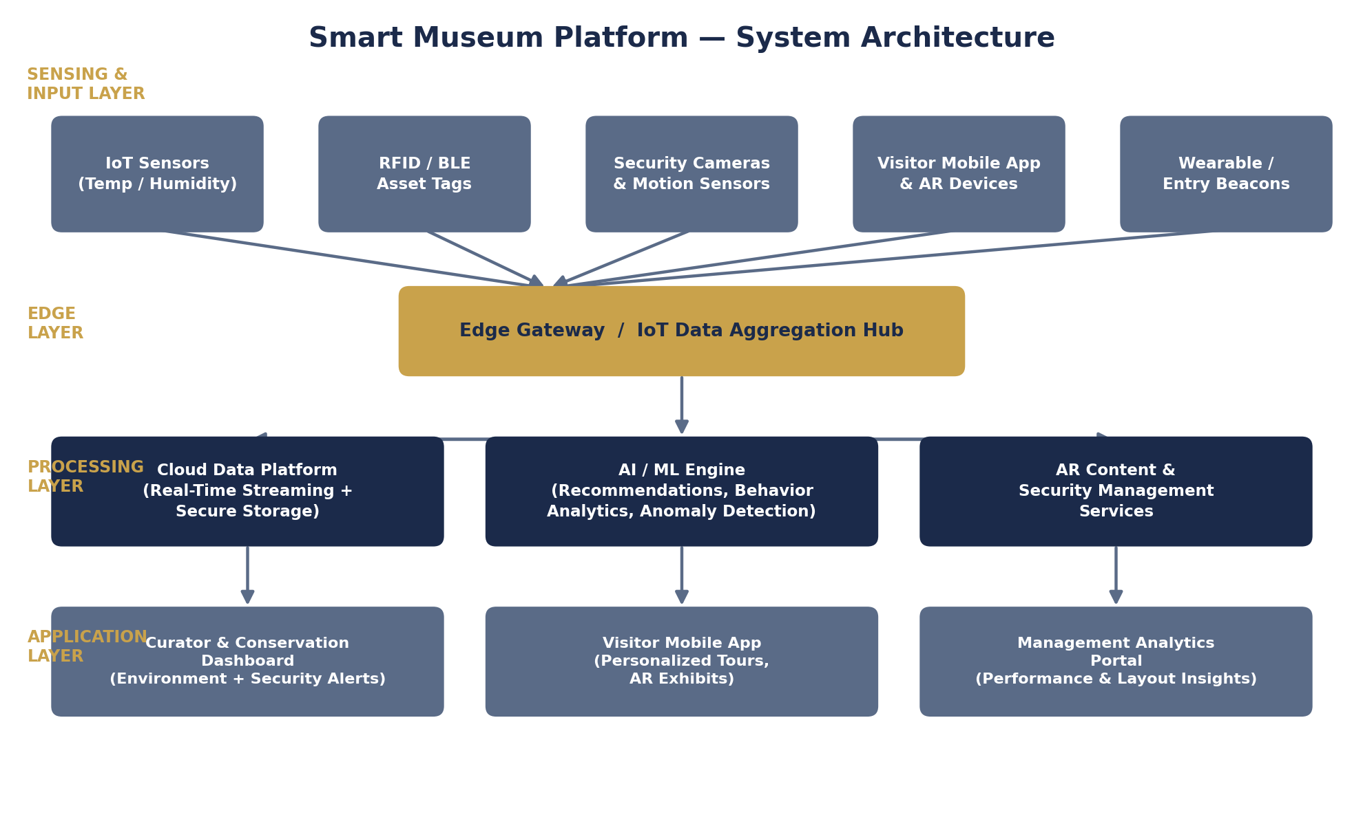
Figure 1. High-level system architecture showing sensing, edge, processing, and application layers.

5.1 Sensing and Input Layer
IoT temperature and humidity sensors, RFID/BLE asset tags, security cameras, motion sensors, and visitor-facing mobile and AR devices continuously capture raw data across the museum floor.

5.2 Edge and Processing Layers
An edge gateway aggregates sensor data locally for low-latency alerting before forwarding it to the cloud platform, where a dedicated AI/ML engine performs recommendation generation, behavior analytics, and anomaly detection alongside secure, real-time data storage.

5.3 Application Layer
Processed insights are surfaced through three purpose-built interfaces: a curator and conservation dashboard for environmental and security alerts, a visitor mobile app for personalized tours and AR content, and a management analytics portal for museum-wide performance reporting.

6. Key Features and Functional Modules

6.1 IoT-Based Artifact Environmental Monitoring
Wireless IoT sensors placed within display cases and storage areas continuously track temperature, relative humidity, and light exposure for each artifact or gallery zone. Readings are compared against conservation-safe thresholds defined for each artifact type, and the system issues automated alerts to conservation staff the moment a reading drifts outside its safe range — enabling preventive action before physical damage occurs.
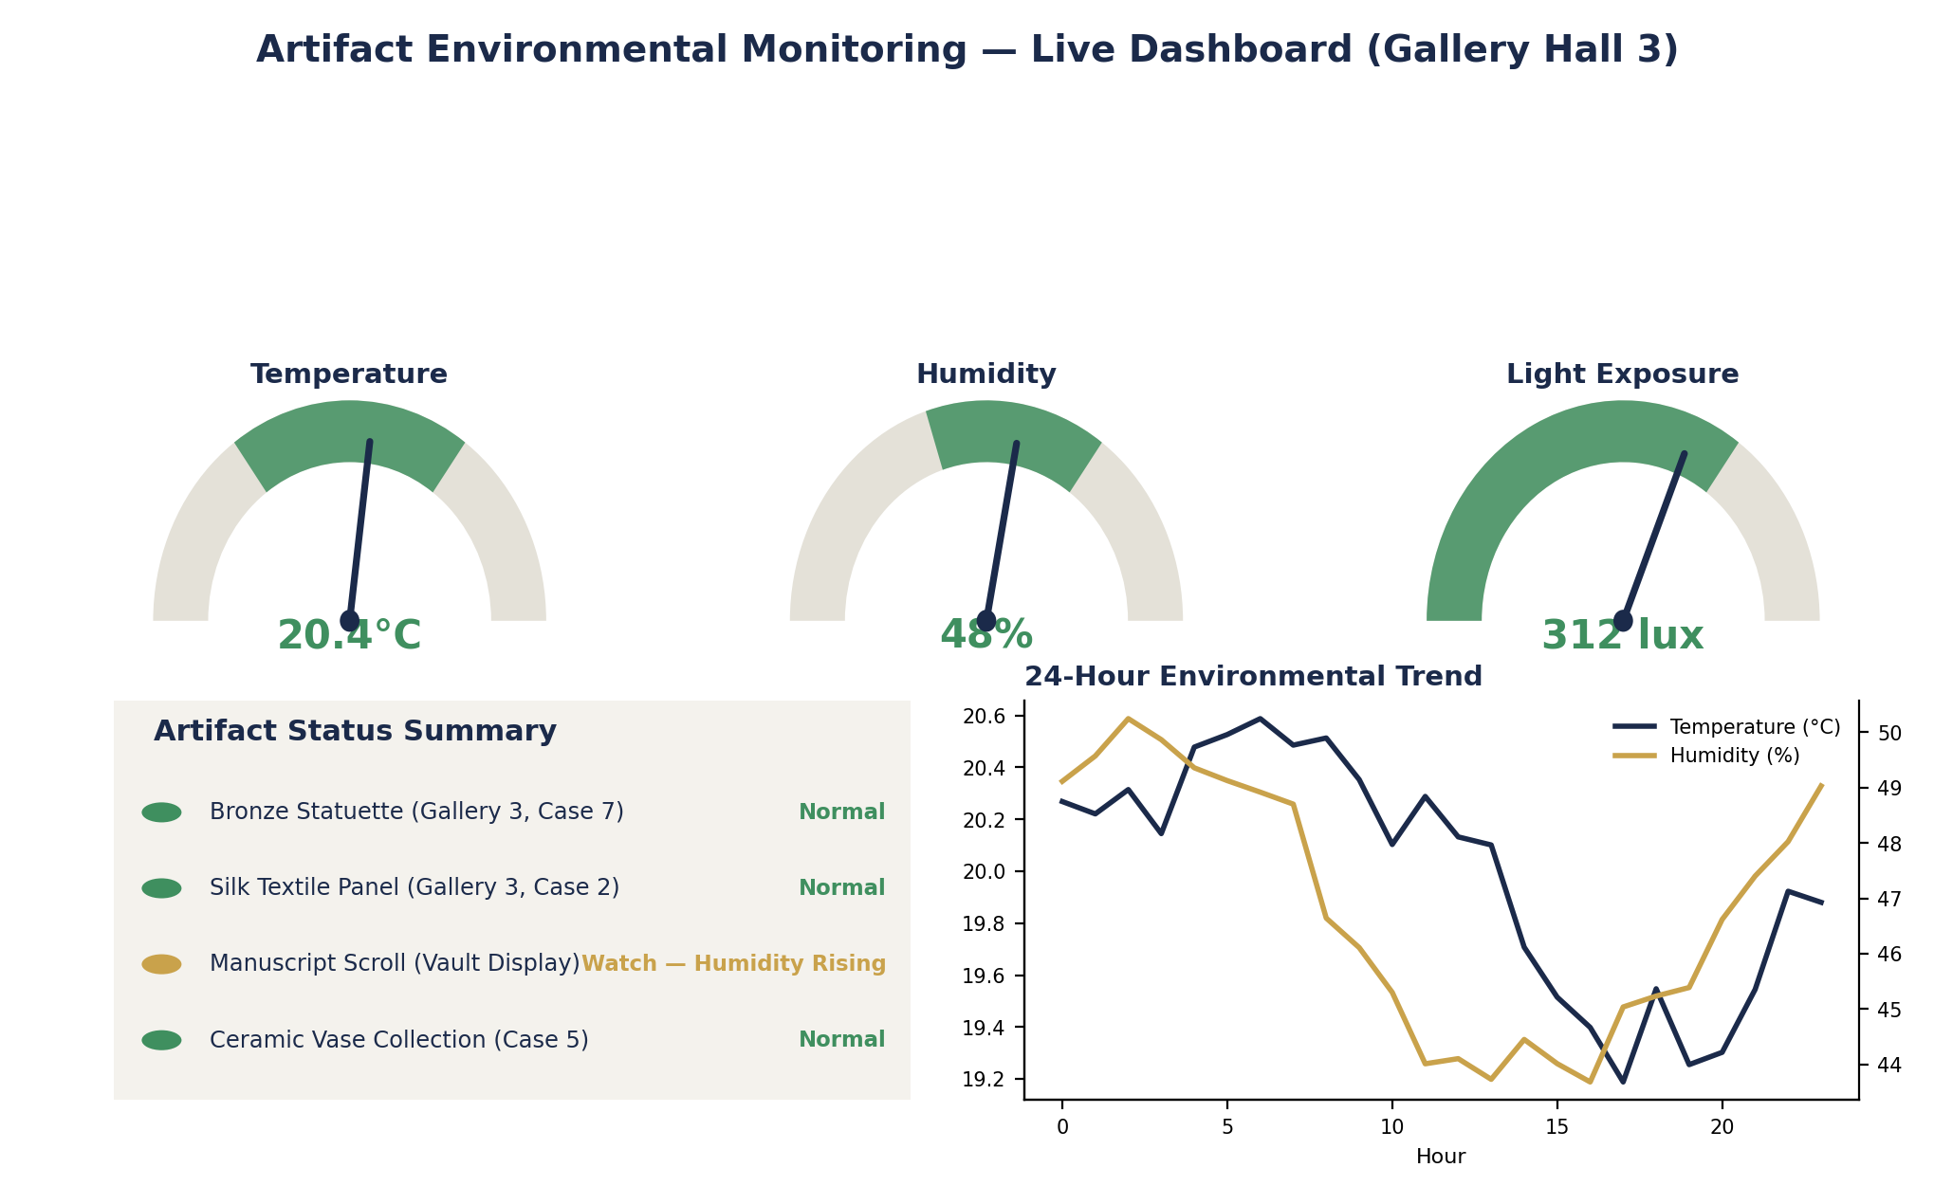
Figure 2. Example real-time artifact environmental monitoring dashboard.

6.2 AI-Powered Personalized Tour Recommendations
Using visitor-provided interests, time budget, and in-museum behavior signals, the AI recommendation engine dynamically builds and adjusts a suggested tour route. This reduces congestion at popular exhibits by intelligently sequencing suggested paths and increases the likelihood that visitors engage meaningfully with content aligned to their interests.

6.3 Augmented Reality (AR) Interactive Exhibits
AR overlays deliver contextual storytelling, 3D reconstructions, and interactive annotations layered directly onto physical exhibits when viewed through a mobile device or AR headset. This transforms passive viewing into an interactive learning experience, particularly valuable for fragile artifacts that cannot be physically handled.

6.4 Enhanced Security Monitoring
RFID tagging combined with camera-based motion analytics enables real-time detection of unauthorized artifact movement, tampering, or restricted-area access, with automated alerts routed to security personnel and full audit trails for compliance and incident review.

6.5 Visitor Behavior and Preference Analytics
Aggregated, privacy-respecting movement and interaction data reveals which exhibits generate the greatest engagement, where bottlenecks form, and how dwell time varies by zone — informing both real-time crowd management and longer-term exhibition redesign.
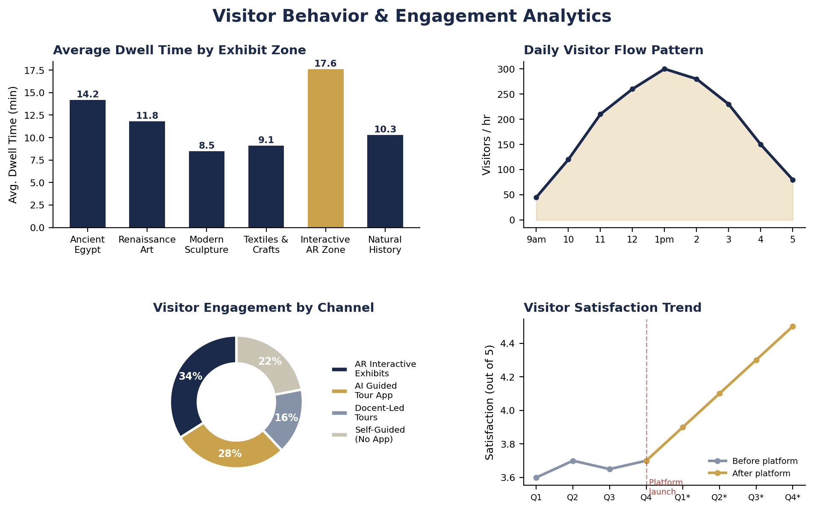
Figure 3. Sample visitor behavior and engagement analytics dashboard.

6.6 Museum Performance Analytics
Consolidated reporting on attendance trends, exhibit popularity, tour completion rates, and visitor satisfaction gives museum management the data foundation needed for evidence-based planning and resource allocation.

7. Technology Stack Overview
The following table summarizes the primary technology layers underpinning the platform and their role within the overall system.
Layer | Representative Technologies | Purpose
Sensing | IoT temperature/humidity sensors, RFID/BLE tags, CCTV & motion sensors | Capture environmental, location, and security data
Connectivity | Wi-Fi, BLE, LoRaWAN, Edge Gateway | Reliable, low-latency data transport from devices to cloud
Cloud & Data | Cloud storage, real-time streaming pipeline, secure database | Centralized, scalable storage and processing
AI / ML | Recommendation models, behavior analytics, anomaly detection | Personalization, insight generation, alerting
Experience | AR/AI mobile application, curator dashboard, analytics portal | Visitor engagement and staff decision support

8. Expected Outcomes
Successful implementation of the platform is expected to deliver measurable benefits across visitor experience, artifact preservation, and museum operations:
- Improved visitor experience through personalized, interactive engagement.
- Enhanced artifact preservation via continuous, real-time environmental monitoring.
- Increased museum engagement driven by AR-based interactive learning.
- Better exhibition planning informed by data-driven visitor behavior analytics.
- Improved security and monitoring through automated, real-time alerting.
- Data-driven museum management supported by consolidated performance analytics.
- Higher visitor satisfaction resulting from more relevant, engaging visits.
- Sustainable cultural heritage conservation through proactive, preventive care.

9. Conclusion
The Smart Museum Visitor Experience and Artifact Monitoring Platform offers a practical, integrated response to the dual challenge facing modern museums: protecting irreplaceable cultural heritage while delivering the engaging, personalized experiences today's visitors expect. By combining IoT-based environmental monitoring, RFID and camera-based security, AI-driven personalization, and AR-based interpretation within a single cloud-connected architecture, the platform equips museums to make faster, better-informed decisions across conservation, security, and visitor engagement.
Phased adoption — beginning with environmental monitoring and security modules before layering in AI personalization and AR content — offers a pragmatic path to realizing these benefits while managing implementation risk and cost.

